Lab 10 Worksheet Karst and Deserts
Name ______ (-2 points if missing)
Date _______
Use your textbook, lab and lecture PowerPoints, and internet as needed to answer all questions in each of the 2 parts. Please explain everything in your own words.
Part 1 Karst Topography
Maps to use: Lake Wales, FL; Mammoth Cave, KY
General questions
- What rock type is prone to producing karst topography?
  - Gypsum
- Where are three places in the US prone to karst topography?
  - Alaska
  - Hawaii
  - Virgin island
- In initial stages of karst development, what is the first feature to be visible at the surface?
  - Depocenter / sedimentary basin
- What karst features will develop at mid-stage of development?
  - Sinkholes, vertical shafts, disappearing streams, foibe and reappearing springs.
- What karst features will develop at extreme late stage of development?
  - Very large caves, disappearing sinkholes.
- How do solution valleys form?
  - The river flows over the limestone until the joints have to open up sufficiently and the stream disappears down a swallow holes.
- What museum had a sinkhole open under the floor, swallowing exhibit items?
  - Corvette Museum
Lake Wales, FL
- What are all those round depressions and lakes?
  - Are karst closed depression with permanent lake.
- If you were offered a home for a cheap price next to Lake Belle, would you buy it?
  - No, because areas near the lakes are prone to flooding and Mosquitoes.
- What does the presence of so many lakes tell you about the water table?
  - This shows that the water table is closer to the surface.
- Why are some of these lakes strangely shaped?
  - They are strangely shaped either naturally or it is artificially due to the human intention to give them excellent views due their sizes.
- What is the stage of development seen in this map?
  - Age of high Mass consumption

- Are there any disappearing streams in this map?
  - Yes
Mammoth Cave, KY
- What direction does Sinking Creek flow?
  - North east
- What happens to Sinking Creek downstream?
  - There is losing stream, disappearing streams influent stream is the river that continues to loss the water as it flows downstream.
- What type of stream is Sinking Stream?
  - Is when the conduit-flow capacity is greater than Maximum allogeneic discharge?
- What stage of karst development is on this map?
  - Mid-stage of karst development
- Identify at least 3 knobs on this map.
  - Wolf knob
  - Huckleberry knob
  - Pine knob
- Besides Mammoth Cave, name 3 other caves shown on this map.
  - Green river cave
  - Linyphiid cave
  - Carabid cave
Part 2 Desert
Maps to use: Ontario, CA
General questions
- What feature forms when multiple alluvial fans join together?
  - Bajada
- What feature of deserts is shown in this image?

  - 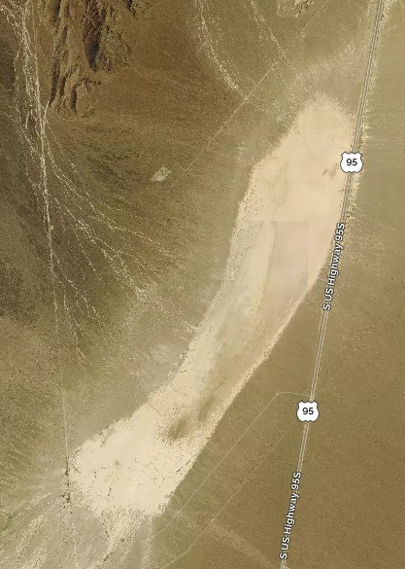
  - Underground water channel.
- Explain the difference between a plateau, mesa, and butte.
  - The buttle once was part of the flat elevated land called plateau or Mesa. Their only difference was driven from their size, that the buttle is considered taller than it is wider and the Mesa was relatively larger and was slightly less elevated.
- What is a hoo doo?
  - This is a thin, tall rock spire protruding from the bottom of an arid.
- Identify at least 3 desert landforms in this image.
  - 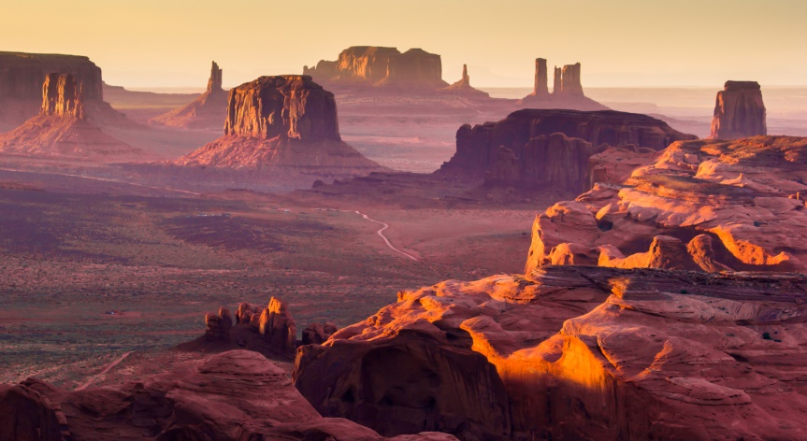
  - Valleys
  - Canyons
  - Rock pedestals
- Which are most common in the desert environment: gaining streams or losing streams (Hint: think back to Lab 11)?
  - Gaining streams.
- What direction is the wind from in this image?
  - 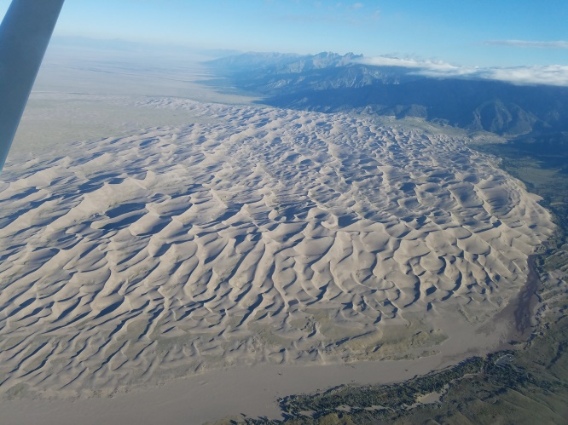
  - west
- What are the 5 major types of dunes?
  - crescentific
  - linear
  - parabolic
  - star
  - dome
- What is the name of the driest desert on Earth?
  - Atacama desert
Ontario, CA
- What type of desert features in found south of the bright green area, coming out of the mountains? (Hint: observe the shapes of the contour lines)
  - oasis
- In previous maps, we saw intermittent streams turn into perennial streams. In this map, the perennial streams turn into intermittent streams. How would you explain this?
  - This is because the intermittent stream seasonally becomes dry as when there is a drop of the water table below the elevation of streambed during dry periods.
- Identify 3 streams that start perennial, and become intermittent.
  - Seasonal streams
  - Alluvial Fans
  - deltas

